**Note:**

1. The path is different from the one you’ll type if you download and run my project. You should just type: “http://localhost/UI_Website_Laravel/public/UI_Website_Blog”
2. If I am remembering correctly, you told us to not sumbit the “vendor” file as part of our source code so I did not include that in the submission. **Note that you get this error if vendor is not included.**

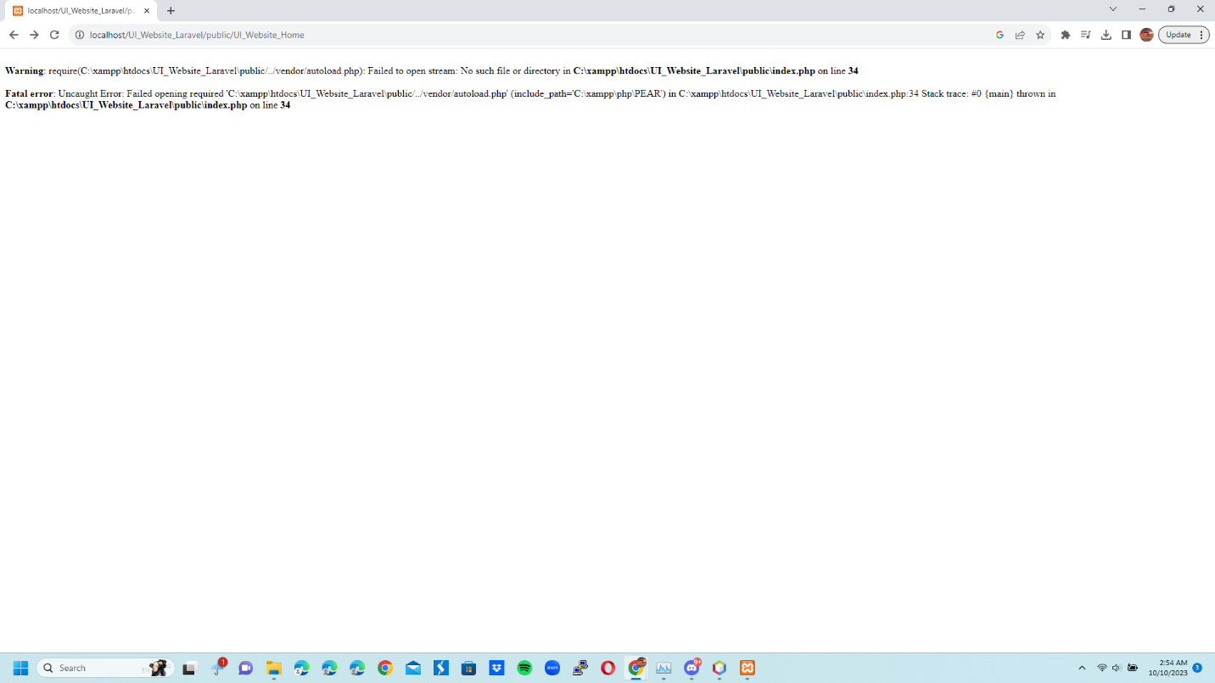

1. I also don’t know if we needed to upload from github. The assignment didn’t say to so I didn’t.

UI_Website_Home: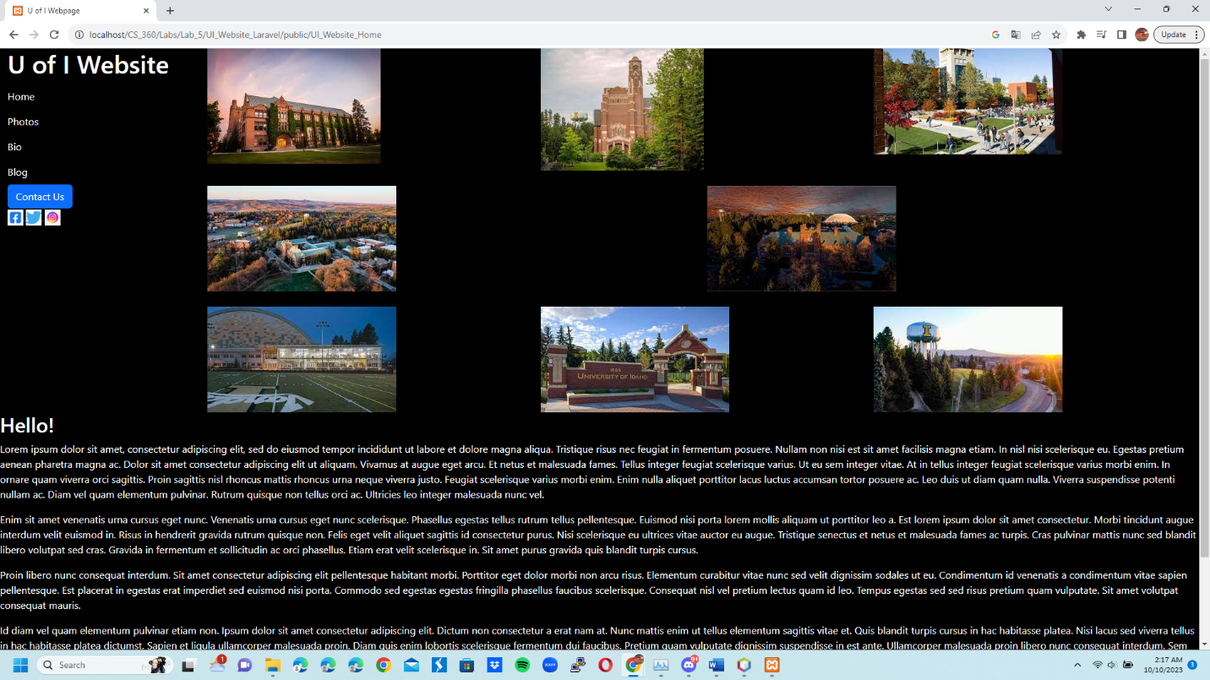

2 UI_Website_Photos:

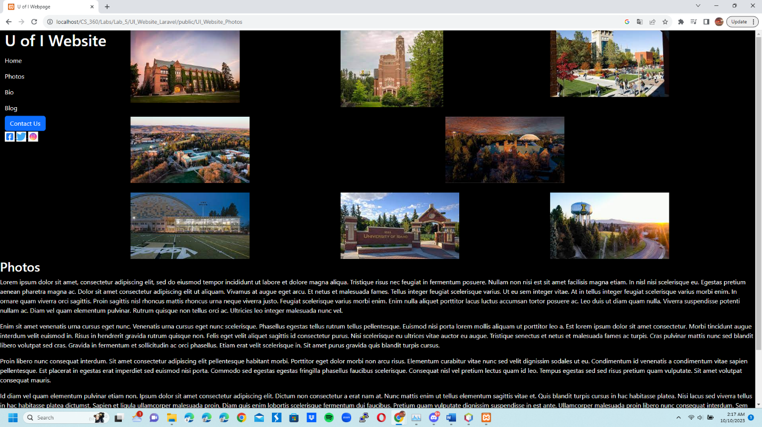

3 UI_Website_Bio:

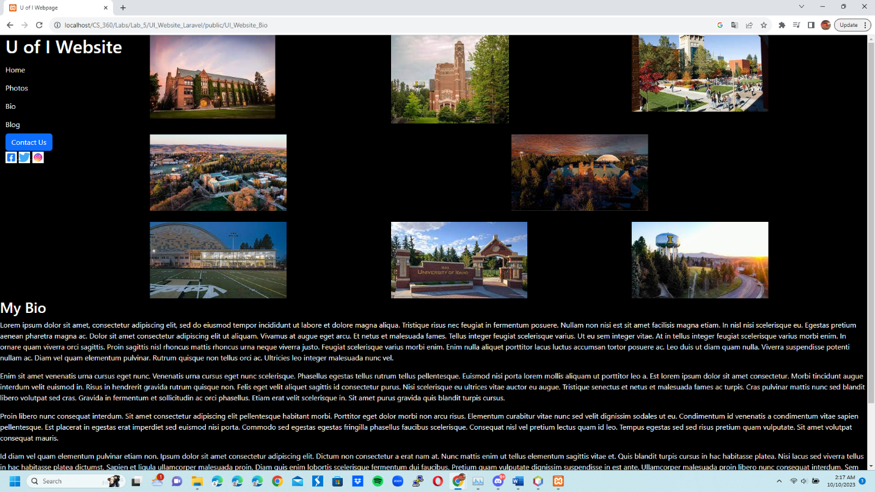

4 UI_Website_Blog:

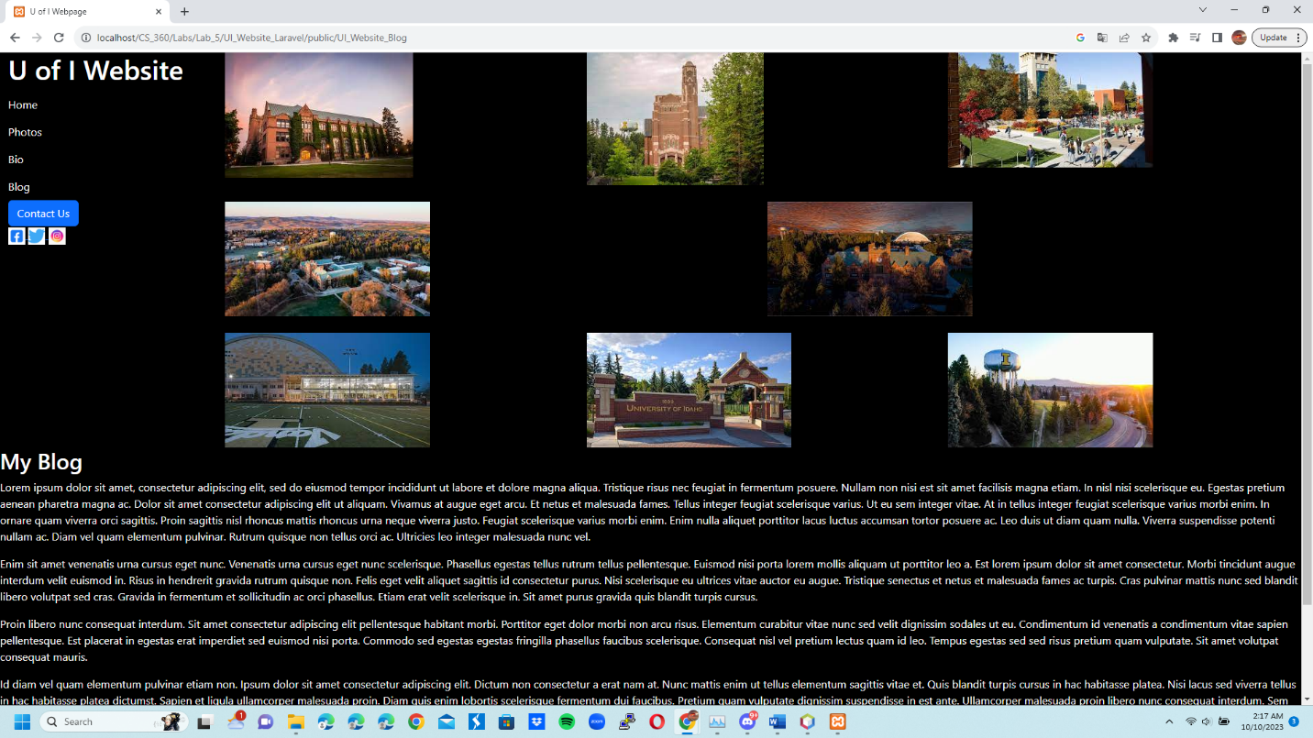

5 UI_Website Contact Us 1:

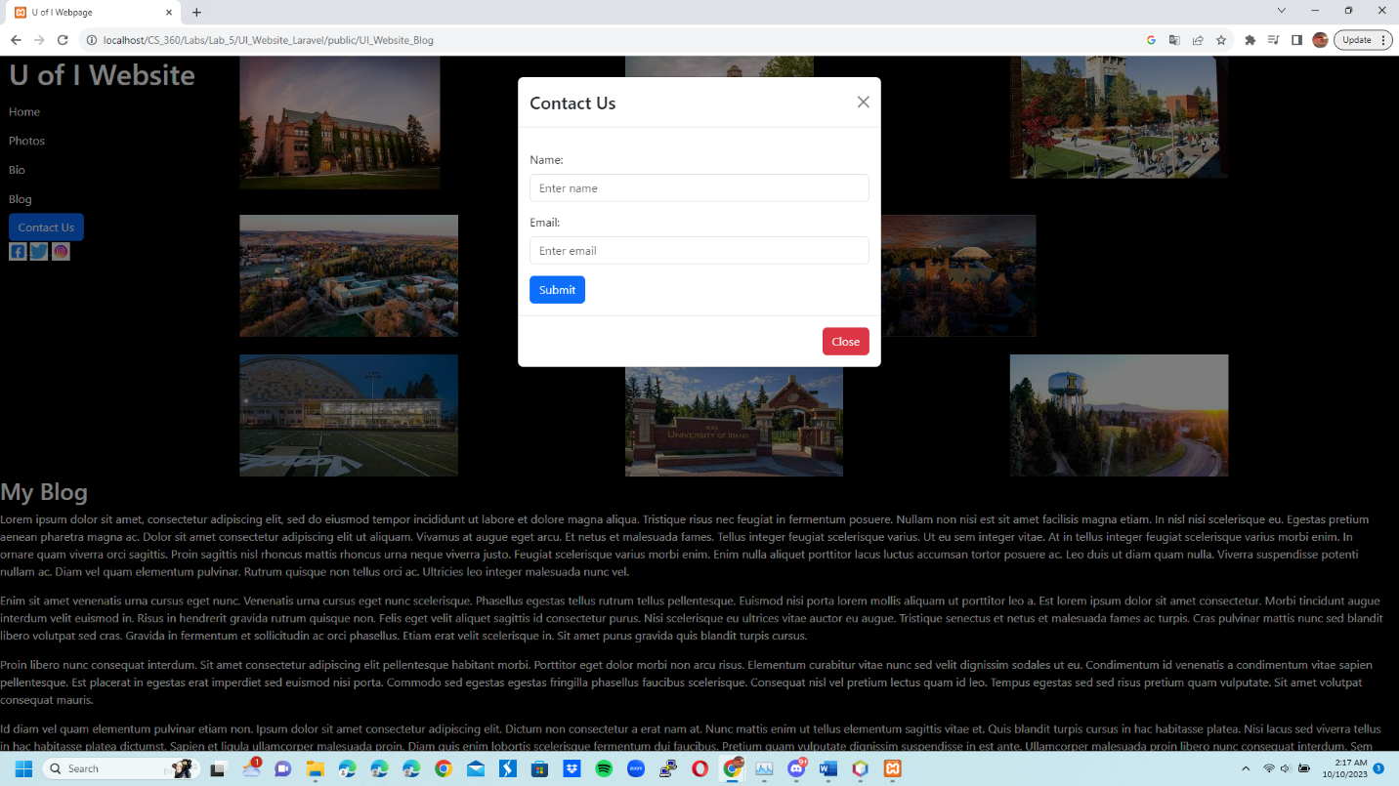

6 UI_Website Contact Us 2:

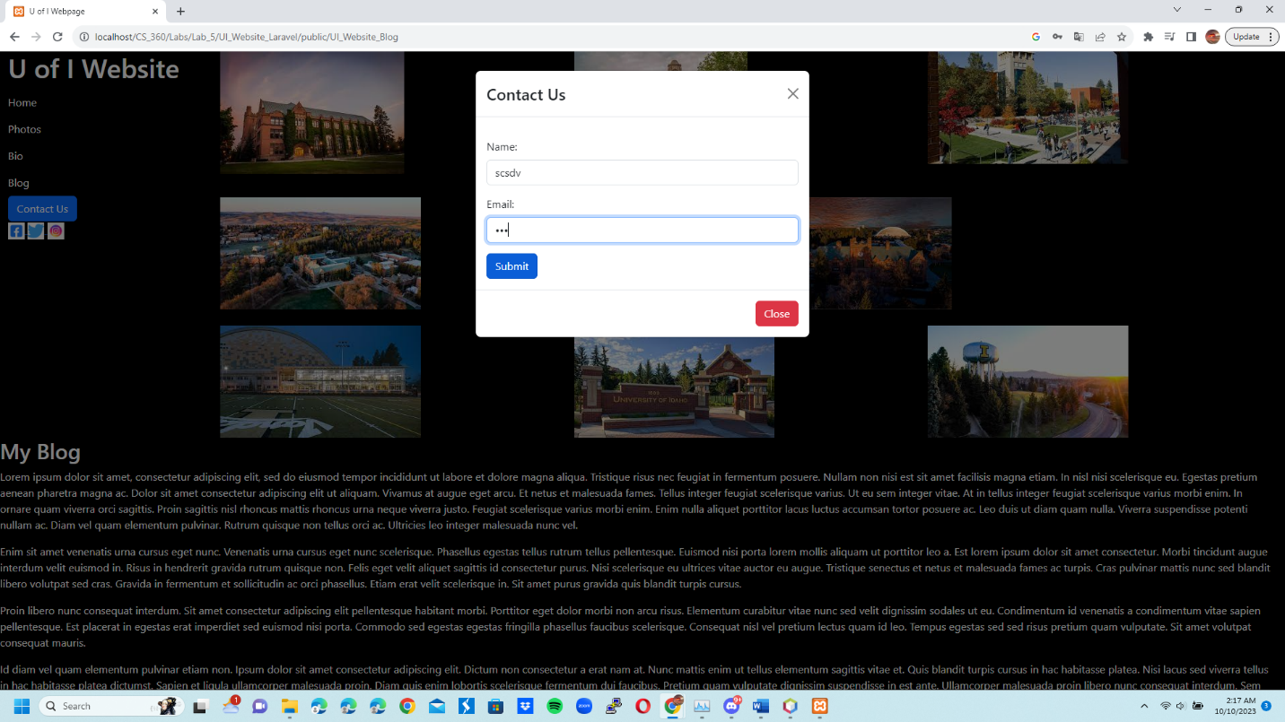

7 UI_Website Picture 1:

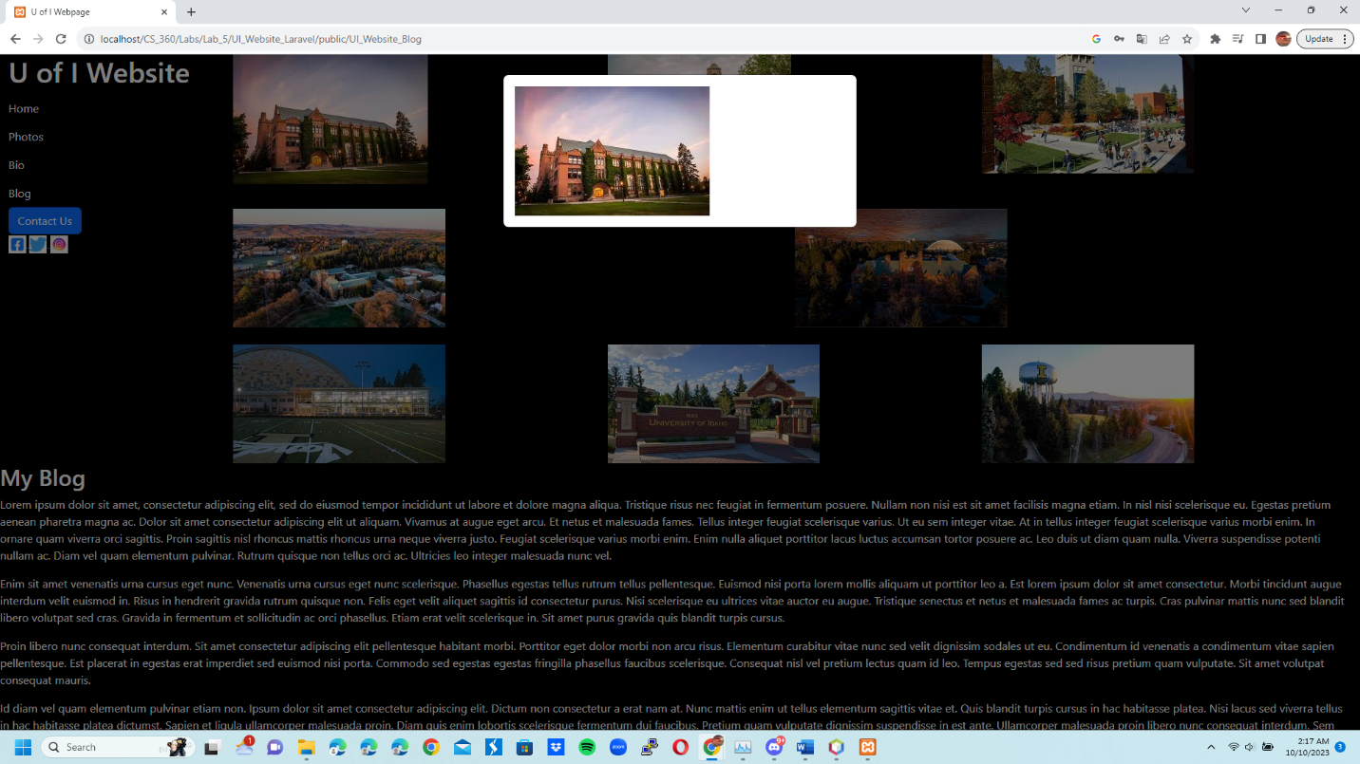

8 UI_Website Picture 5:

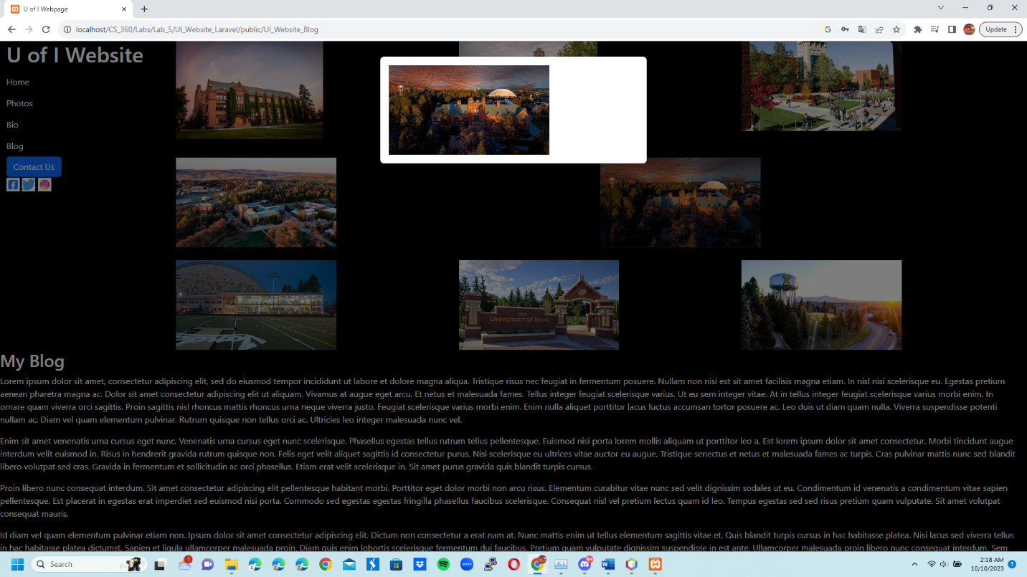

9 UI_Website Picture 8:

